Fifth Grade Supply List

School Year

- blue plastic folder – 2 pocket (This will be used as our homework folder.)
- 4 plastic solid colored folders with pockets (red, blue, green, yellow)
- 1 pack of colored pencils
- 1 box of 24 crayons
- 2 glue sticks
- 1 pair of scissors
- 1 pencil pouch/box
- pencils (24)
- 2 extra-fine sharpies
- 2 composition books – marble; wide-rule
- 2 one-subject spiral bound notebooks (one green, one red)
- headphones/ear buds
- container of antibacterial wipes
- 2 boxes of tissues
- 2 different colored highlighters
- 4 pack of expo markers
- eraser for whiteboard (sock, mitten, etc.)
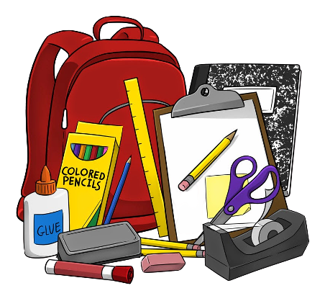
Thank you,
The Fifth Grade Team

